TITLE: SDM CampusFlow
ABSTRACT:
CampusFlow is a social media web application designed specifically for students and faculty of SDM College of Engineering and Technology. It allows users to connect, share updates, form communities, and advertise campus events such as hackathons and cultural fests. The platform offers robust features like user authentication, friend (rapport) requests, and a secure environment restricted to the college's verified members. The goal is to facilitate interaction between students and faculty and provide a platform for collaboration, communication, and networking.

INTRODUCTION:
CampusFlow is a modern web application that aims to enhance student engagement within the college ecosystem by providing a platform for social interaction. In a digitally connected world, students often need a space to interact with peers and faculty beyond academic discussions. CampusFlow creates a community-focused digital environment where users can share ideas, join events, and network with like-minded individuals.

PROBLEM STATEMENT:
Many students in college find it difficult to connect with others, especially across different departments and years. There is no dedicated platform for students and faculty to communicate, collaborate on academic projects, or promote campus events. The existing social media platforms are too broad and not designed for academic or campus-centric interactions.

HARDWARE and SOFTWARE Requirements:
- Hardware: Standard web server and client machines.
- Software:
  - Backend: Django 5.0
  - Frontend: Jinja2, HTML5, CSS
  - Database: SQLite / PostgreSQL
  - Operating System: Ubuntu
  - Tools: Visual Studio Code, Git

OBJECTIVE OF THE PROPOSED WORK:
The objective of CampusFlow is to:
  - Provide a private and secure social media platform exclusively for SDM College.
  - Allow students to connect with peers and faculty members.
  - Promote campus events and academic discussions.
  - Enable students to form communities based on shared interests.
  - Create a robust authentication system ensuring only legitimate users from the campus can register.

METHODOLOGY OF THE PROPOSED WORK:
CampusFlow will be built using Django as the backend framework, utilizing a robust authentication system where each user registers using their USN (University Seat Number). A Many-to-Many relationship will manage friend (rapport) connections, and a separate model will track advertisement postings and event promotions. Notifications will be integrated to inform users of pending rapport requests and new events. The frontend will utilize Jinja templating for dynamic content rendering. For now the CampusFlow app is created on monolithic architecture, plan is to revolutionize it to decoupled architecture for mobile app in future.

MODEL DIAGRAM:
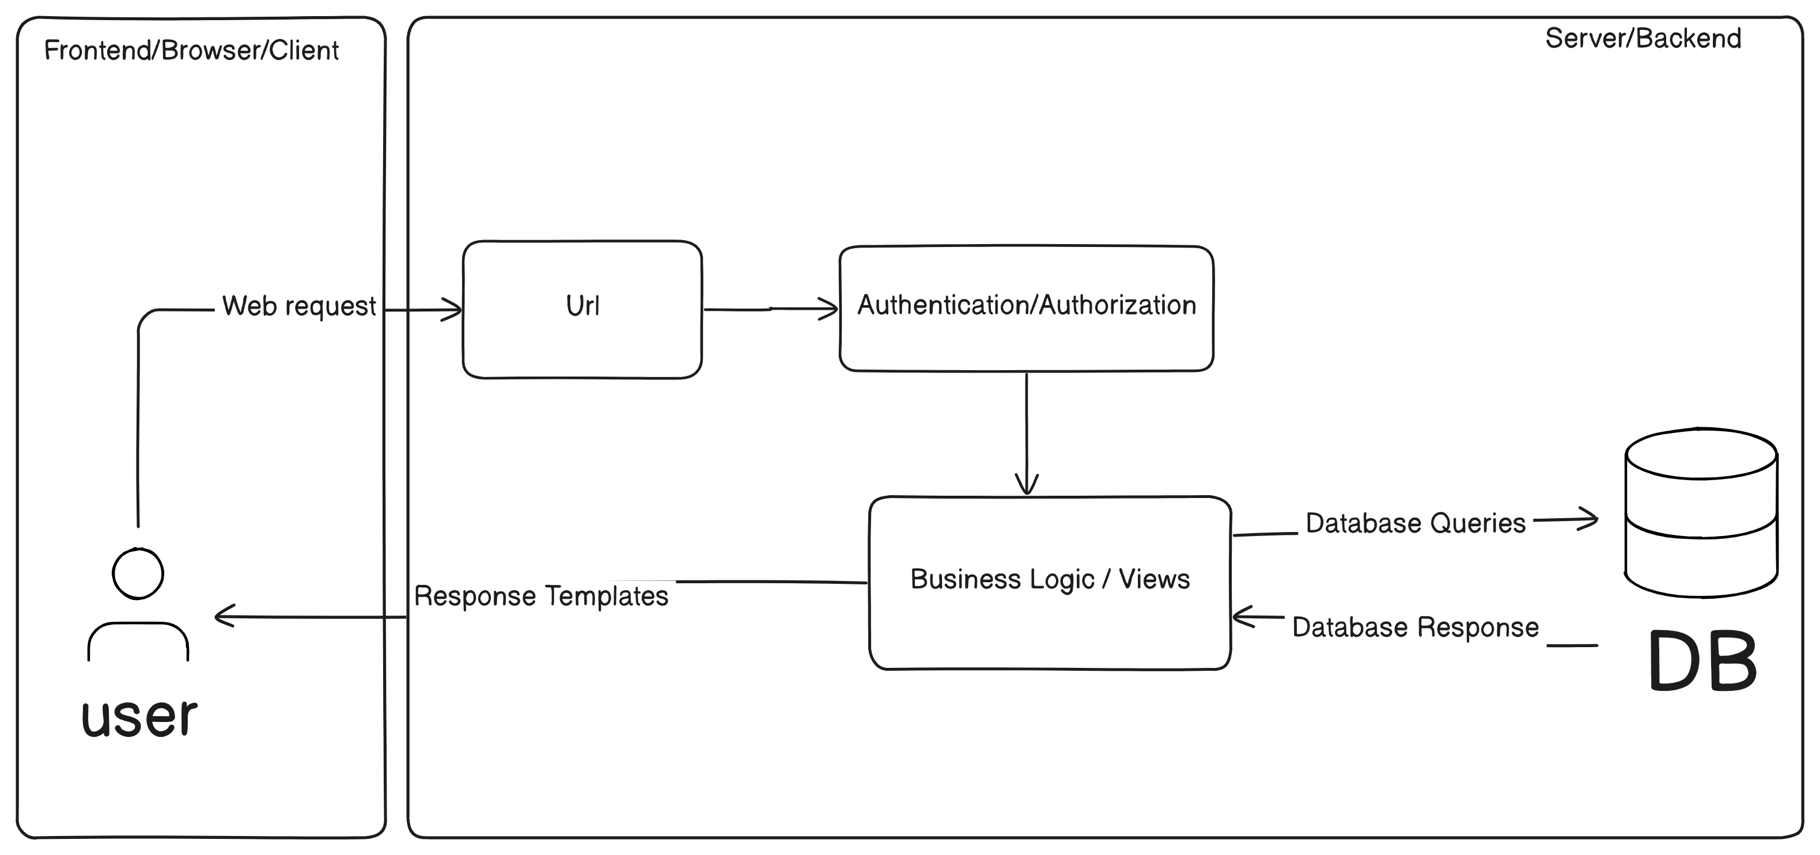
EXPECTED OUTCOME OF THE PROPOSED WORK:
Upon completion, CampusFlow will:
  - Provide a seamless platform for SDM College students and faculty to interact.
  - Enhance event participation by offering a dedicated space for advertisements.
  - Promote collaboration through community formation based on common interests.
  - Offer a streamlined user experience tailored to the academic environment.

APPLICATION:
Networking platform for students and faculty.
- Advertisement hub for campus events, academic clubs, and study groups.
- Community formation around shared interests such as coding, design, or research.

CONCLUSION:
CampusFlow aims to bridge the communication gap within SDM College by providing a dedicated platform for students and faculty to interact. It will foster collaboration, promote campus culture, and streamline event management, creating a more connected and engaged campus community.

REFERENCES:
- Django Documentation, https://docs.djangoproject.com/
- PostgreSQL Documentation, https://www.postgresql.org/docs/

- Jinja2 Documentation, https://jinja.palletsprojects.com/

